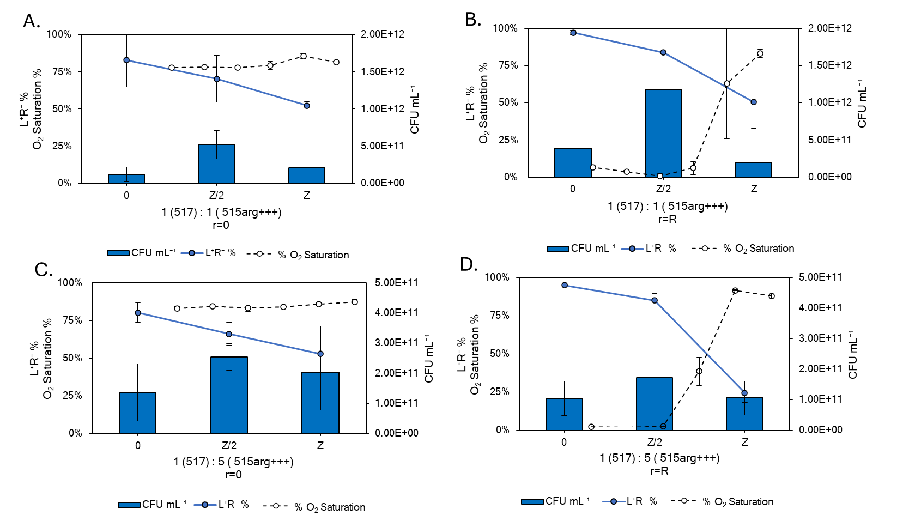

**Supplementary Material S4. Two dimensional, spatial analysis of dissolved O2, strain percentage (L+R-), and cell density per volume for coculture 3 inoculated at 1 L+R- :1 L-R+ (subplots A and B) and 1 L+R- : 5 L-R+ (subplots C and D).** Subplots A and C present data from the center of the biofilm (r= 0) which is not metabolically active based on no O2 consumption. Subplots B and D present data from the outer edge of the biofilms (r= R) which is metabolically active with dissolved O2 levels decreasing with depth into the biofilm (Z).